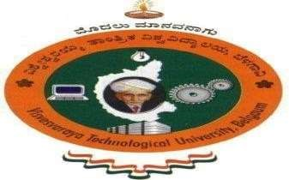
VISVESVARAYA TECHNOLOGICAL UNIVERSITY
JNANA SANGAMA, BELAGAVI-590018

A Internship Report
ON

“DATA SCIENCE DOMAIN INTERNSHIP”

Submitted in partial fulfilment for the award of degree of Bachelor of Engineering
in
Computer Science & Engineering (Data Science)
during the year 2026-2027

Submitted by :
Nagabhushana Raju S - 4MH22CD034

Internship Carried out at:
- NYERA EDUTECH & INNOVATIONS PVT.LTD

Under the guidance of :
Prof. M S Chandrashekara
Internship Coordinator
Dept. of CSE (Data Science)
MITM

Ramkumar
Manager & Internship Incharge
- NYERA EDUTECH & INNOVATIONS PVT.LTD

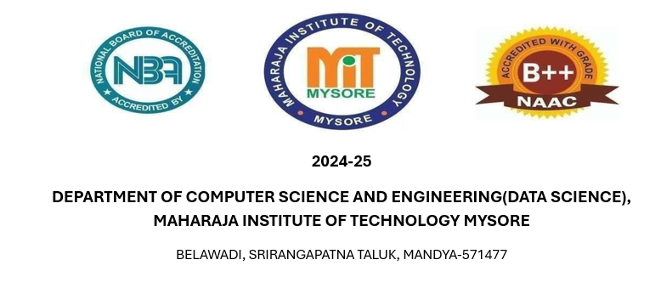

DEPARTMENT OF COMPUTER SCIENCE AND ENGINEERING
(DATASCIENCE)
MAHARAJA INSTITUTE OF TECHNOLOGY MYSORE
MANDYA — 571477.
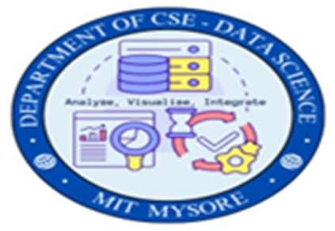
CERTIFICATE

This is to certify that Ms. NAGABHUSHANA RAJU S [4MH22CD034], a bonafide student of Maharaja Institute of Technology Mysore, has successfully completed the Internship as a part of the Bachelor of Engineering program in Computer Science and Engineering (Data Science) during the academic year 2025–2026.
The internship was carried out at - NYERA EDUTECH & INNOVATIONS PRIVATE LIMITED., where the student actively participated in assigned tasks and gained practical knowledge relevant to the field of study. This Internship report submitted by the student is a bonafide record of the work carried out during the internship period and has been approved as it satisfies the academic requirements prescribed by Visvesvaraya Technological University, Belagavi.
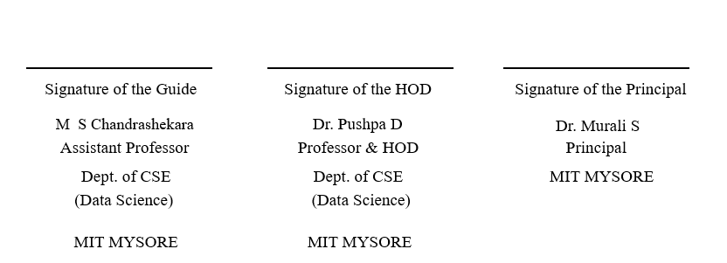

< EXTERNAL VIVA >

Name of the Examiners Signature with date


1.

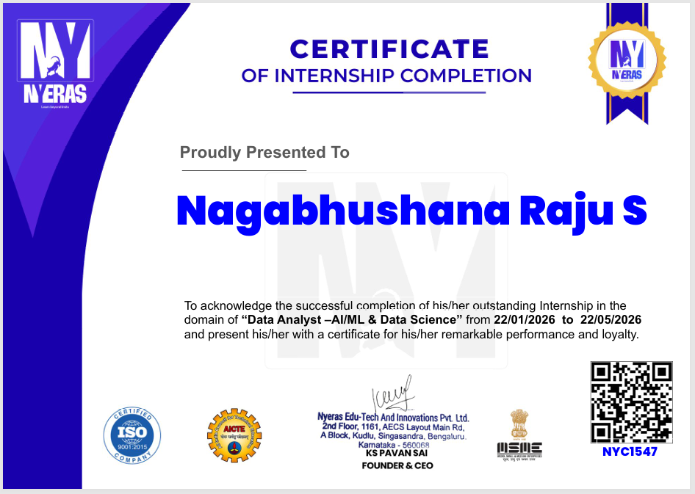

DECLARATION

ACKNOWLEDEGEMENTS

I take this opportunity to express my sincere gratitude to Maharaja Institute of Technology Mysore for providing me with the opportunity to undertake this internship as a part of my academic curriculum.
I express my deep sense of gratitude to Dr. Murali S, Principal, Maharaja Institute of Technology Mysore, for providing a supportive academic environment and encouraging practical learning.
I would like to thank Dr. Pushpa D, Professor and Head, Department of Computer Science & Engineering (Data Science), for her valuable guidance and continuous support throughout the internship.
I am extremely grateful to my internal guide for their constant encouragement and guidance during the preparation of this internship report.
I would like to express my heartfelt thanks - NYERA EDUTECH & INNOVATIONS PRIVATE LIMITED. for providing me with an opportunity to gain practical exposure and hands-on experience. I sincerely thank my mentor and team members for their guidance and support.
Finally, I would like to thank everyone who directly or indirectly contributed to the successful completion of my internship.

Nagabhushana Raju S [4MH22CD034]

INDEX OF CONTENTS

CERTIFICATE I
ACKNOWLEDGMENTS II
INDEX OF CONTENTS III
- ABOUT THE ORGANIZATION
1.1 | Overview | 02
1.2 | Services | 02

- OBJECTIVES OF INTERNSHIP 03
- LEARNING EXPERIENCES 04-05
- LEARNING OUTCOMES 06-07
- CONCLUSION 08
- DIARY ENTRIES 07
- INTERNSHIP CERTIFICATE 35

